**CLIENT REQUIREMENTS:**

* Main issue - Want to mark a bunch of groups, but the problem is that data is spread over many different apps, filled out last minute.
* Application - keeps track of time as accurately as possible, incentive to fill out, restrict to time they are filling so cannot edit in future.
* TUTOR POV - Once data entered, the tutor wants average time per week for each person working on the project. 2 categories - documentation and coding. How many hours worked on each. What is each person’s role? Want to know if some person is not doing as much work as other members, then flag that and let the tutor know so they can follow up on it later on.
* Some sort of logging in form for the system - doesn’t have to be overly secure, mostly just name (first) and letter of last name maybe.
* DISPLAY/INTERFACE: Wants to use phone majority of time - so wants product to be phone-friendly for both students and tutor. Catered towards mobile application usage.
* OUTPUT - Graphical output - condensed info, don’t want to read too much. Hover-functionality (e.g. for pie chart who did what, how many hours etc.)
* Minimalistic interface - max. 4 graphs per page (desktop), 1 for mobile
* Before submitting - team members can accept task involvement or else can flag privately.
* Keep track of time
* one set piece
* can’t change things later on - daily!! (goes onto lock) ---------
* average time per week each person is working on each project
* 2 categories: documentation and coding
* Roles
* Flagging for teammates who do not do enough work (anon)
* logging in system
* phone
* graphical condensation of data (no reading!) hover functionality
* minimalistic
* ? bar graph for hrs of students
* click to start work, click to finish work - every day
* Keeps track of time accurately
* Can’t change entered data
* Average time per week
* Documentation and coding
* Logging in system
* Available on phone
* Pie charts will be AWESOME. Click on name and see their contribution
* Tutor will add the projects. Unit name, group name and then adding information
* Flexible enough to be used both on phone and laptop
* Updating the info daily
* Secondary feature - flags
* Start and stop the clock feature
* No minimum hours
* All the team members need to confirm a user’s work
* Assign roles to the student. However they can change it and give an alert to the tutor.
* Version tracking required
* Submit time per week (automatic/manual?)

**STAKEHOLDER MAPPING:**

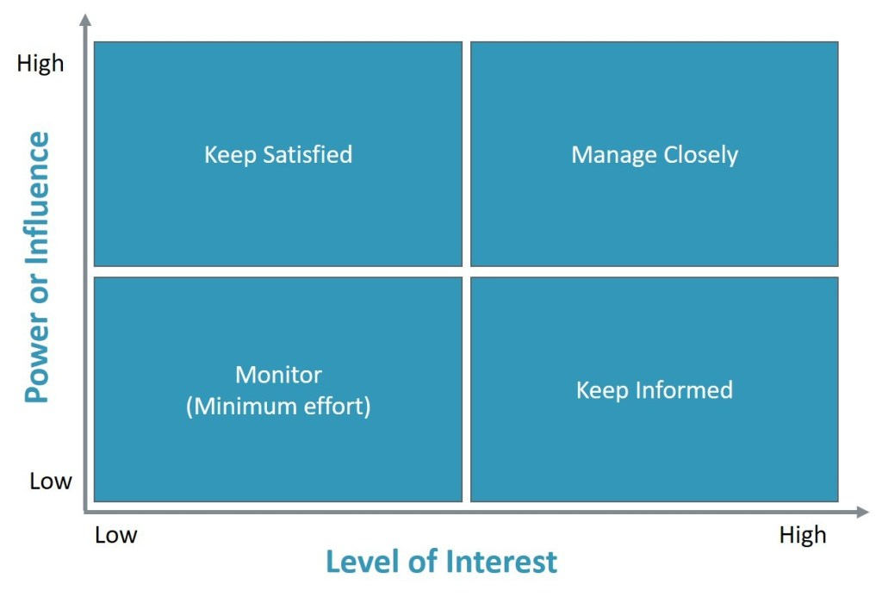

* **Keep satisfied** - Academic board/University (high influence, low interest?)
* **Manage closely**  - Product owner, client (high interest and influence)
* **Monitor** - Lecturers? (Low interest/influence)
* **Keep Informed**  - Student, Marker(high interest, low influence)